Spiral Cable tracer
From ：
Contacts：
Tel:
Fax:
To: Shanghai Power Special Cable Co., LTD.
fone : 021-57137268
Fax : 021-57137568
http://www.sh-spc.com

Quantity Required ___ □once □Required ______in___ year
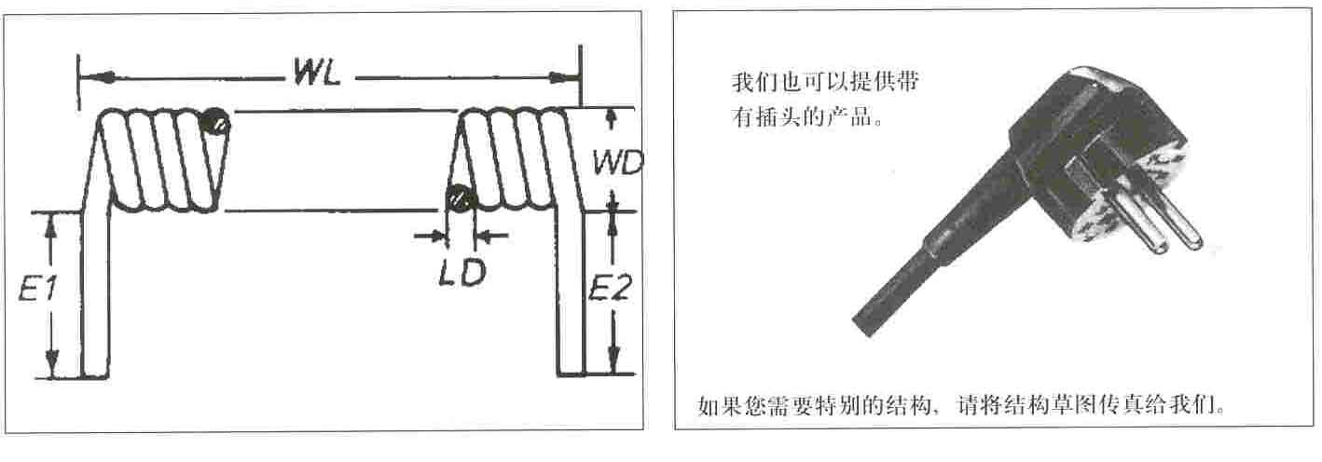

If need a special structure, please fax the structure to us.

1. insulation：□PVC □PE □Teflon □________________
2. jacket：□PVC □PUR □________________
3. color of outer jacket _______________________________________
4. cable structure core number×sectional area：_____×____ + ____×____ mm²
5. shield □yes：___________________
6. length of closed spiral WL=________mm
7. max elongating length / length with elongated spiral _______mm
8. spiral outer diameter WD ______mm
9. cable diameter LD ______mm
10. two ends to stay long E1_______ mm E2_______mm

work environment、long-period working temperature：

